

|  |  |  |  |  |  |  |  |  |
| --- | --- | --- | --- | --- | --- | --- | --- | --- |
|  | | | | | | | | |
|  | | DB LAB 02 | | | | |  | |
|  |  | | | | | | |  |
|  | | | |  |  | | | |
|  | | | | Mohammad Basil Ali Khan(20K-0477) |  | | | |
|  | | | | 09 September 2022—Database and Management System—Sir Ahmed Budhi |  | | | |
|  | | |  | | |  | | |

**Task#01:**

SELECT INITCAP(FIRST_NAME), LOWER(JOB_ID)

FROM HR.EMPLOYEES;

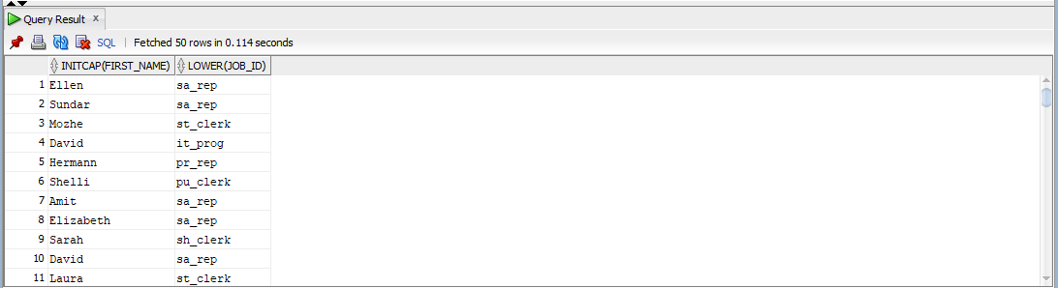

**Task#02:**

**--**Blake was not there in table so consider Steven

SELECT EMPLOYEE_ID, UPPER(FIRST_NAME), DEPARTMENT_ID

FROM HR.EMPLOYEES

WHERE first_name = 'Steven';

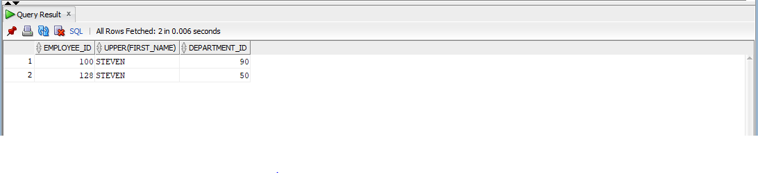

**Task#03:**

--1982 was not there so consider 07

SELECT EMPLOYEE_ID, HIRE_DATE, ROUND(HIRE_DATE, 'MONTH'), TRUNC(HIRE_DATE, 'MONTH')

FROM HR.EMPLOYEES

WHERE HIRE_DATE LIKE '%07';

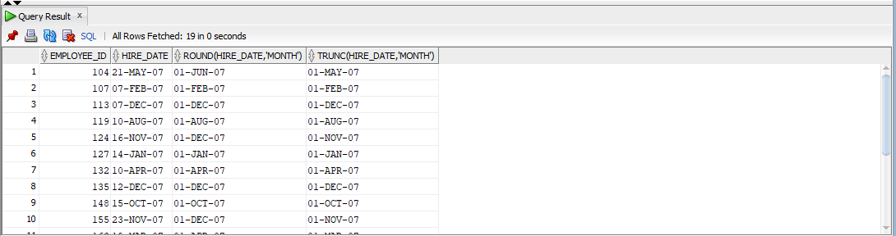

**Task#04:**

SELECT EMPLOYEE_ID, EXTRACT(MONTH FROM HIRE_DATE) AS MONTH_NUMBER, EXTRACT(YEAR FROM HIRE_DATE) AS YEAR_HIRED

FROM HR.EMPLOYEES;

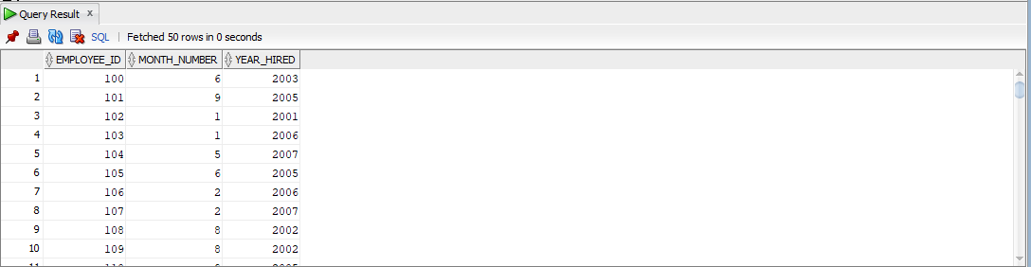

**Task#05:**

SELECT FIRST_NAME, LAST_NAME , JOB_ID, 12 * SALARY

FROM HR.EMPLOYEES;

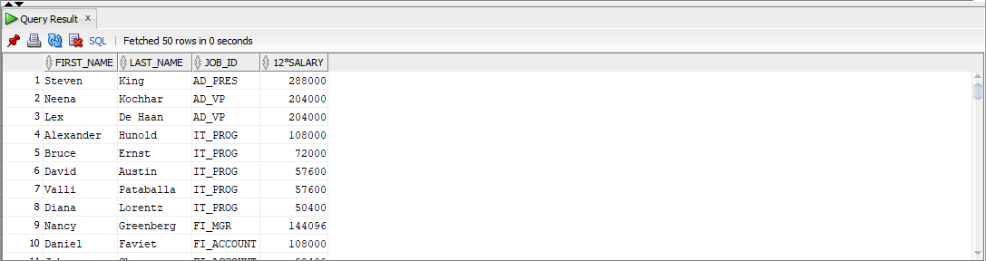

**Task#06:**

SELECT FIRST_NAME, LAST_NAME, SALARY

FROM HR.EMPLOYEES

ORDER BY SALARY;

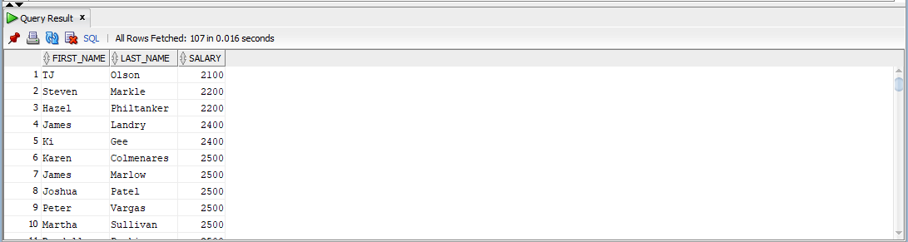

**Task#07:**

SELECT FIRST_NAME, LPAD(SALARY, LENGTH(SALARY) + 1, '$')

FROM HR.EMPLOYEES;

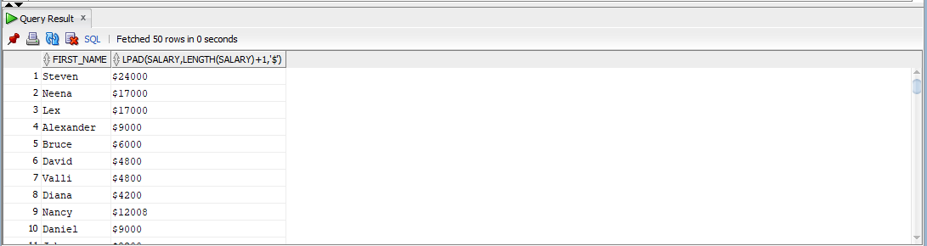

**Task#08:**

SELECT FIRST_NAME, JOB_ID, SALARY

FROM HR.EMPLOYEES

WHERE (SALARY/30) > 100;

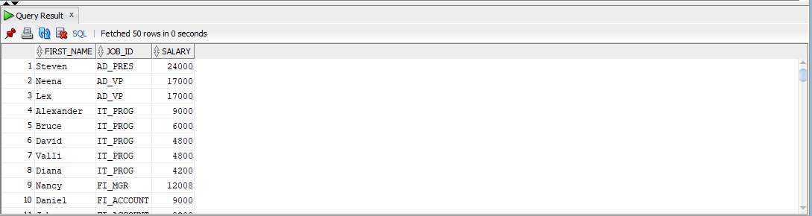

**Task#09:**

SELECT EMPLOYEE_ID, FIRST_NAME, SAlARY, ROUND(SALARY + SALARY * 15/100, 0) AS "New_Salary", ROUND(SALARY + SALARY * 15/100, 0) - SALARY AS "Increment"

FROM HR.EMPLOYEES;

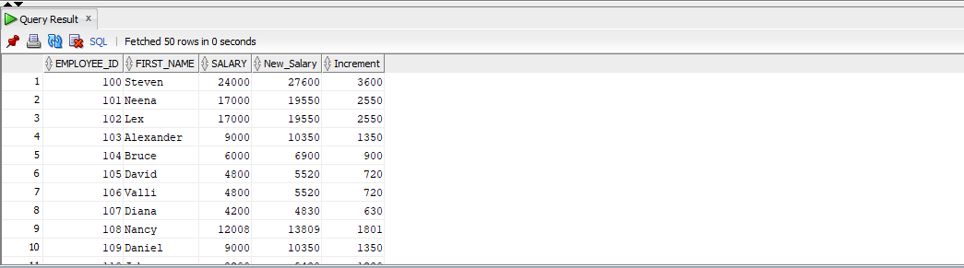

**Task#10:**

SELECT FIRST_NAME, NVL(TO_CHAR(COMMISSION_PCT), 'No Commision') as COMMISSION_PCT

FROM HR.EMPLOYEES;

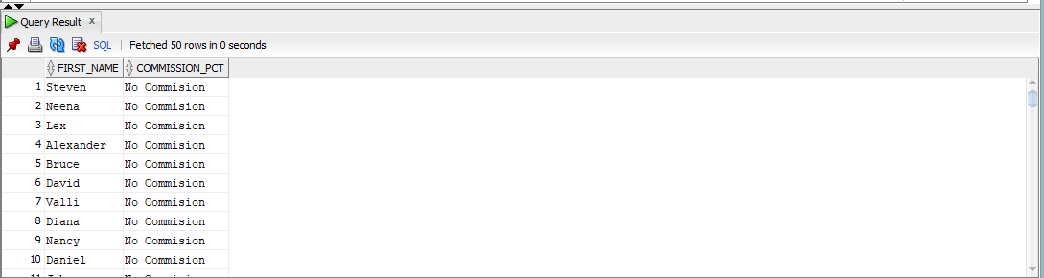

**Task#11:**

SELECT FIRST_NAME, LAST_NAME, HIRE_DATE , EXTRACT(DAY FROM HIRE_DATE) AS "DAY"

FROM HR.EMPLOYEES;

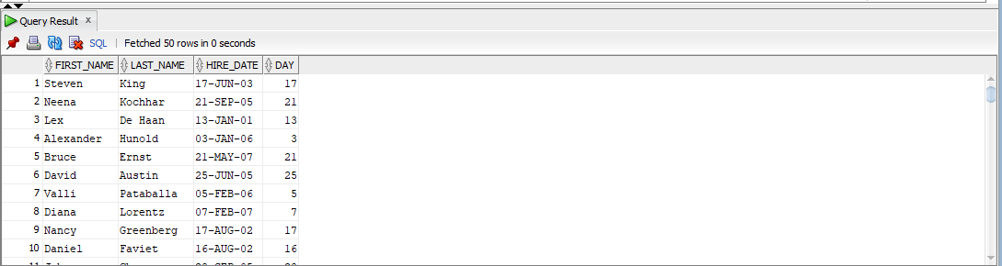

**Task#12:**

SELECT INITCAP(FIRST_NAME) As "Name", LENGTH(FIRST_NAME) As "Length"

FROM HR.EMPLOYEES

WHERE FIRST_NAME LIKE 'J%' OR FIRST_NAME LIKE 'M%' OR FIRST_NAME LIKE 'A%';

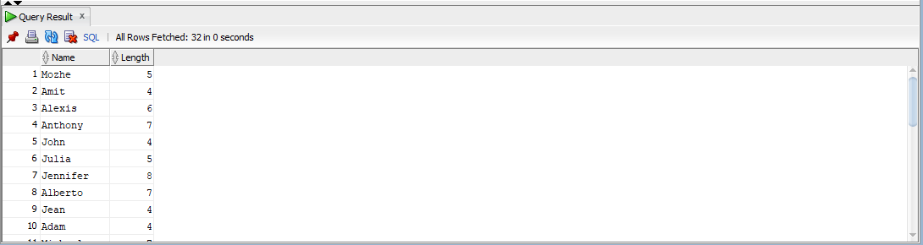

**Task#13:**

--No employee was 35 years old so consider 20

SELECT FIRST_NAME, LAST_NAME, EXTRACT(YEAR FROM HIRE_DATE) AS "JOINED YEAR", EXTRACT(YEAR FROM CURRENT_DATE) AS "CURRENT YEAR"

FROM HR.EMPLOYEES

WHERE EXTRACT(YEAR FROM CURRENT_DATE) - EXTRACT(YEAR FROM HIRE_DATE) = 20;

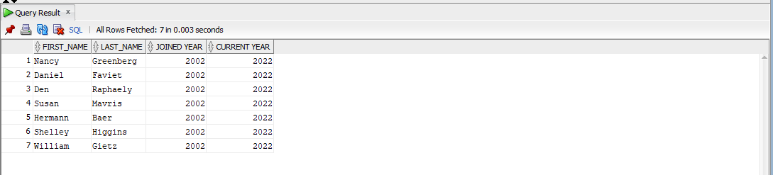

**Task#14:**

SELECT SUM(SALARY)

FROM HR.EMPLOYEES;

